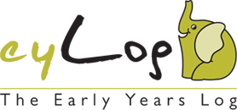
eyLog for Parents

Early Years Foundation Stage (EYFS)

Introduction
The Early Years Foundation Stage (EYFS) is the time in your child’s life between birth and age 5. This is a very important stage as it helps your child get ready for school as well as preparing them for their future learning and success. Your child’s early years’ experience should be happy, active, exciting, fun and secure; and support their development, care and learning needs.
Nurseries, pre-schools, reception classes and childminders registered to deliver the EYFS must follow a legal document called the Early Years Foundation Stage Framework.

EYFS Framework
The EYFS Framework exists to support all professionals working in the EYFS to help your child, and has been developed with a number of early years’ experts and parents. In 2012 the framework was revised to make it clearer and easier to use, with more focus on the things that matter most and has a greater emphasis on the role of parents in helping your child develop. It sets out:
- The legal welfare requirements that everyone registered to look after children must follow to keep your child safe and promote their welfare.
- The seven areas of learning and development which guide professionals’ engagement with your child’s play and activities as they learn new skills and knowledge.
- Assessments that will tell you about your child’s progress through the EYFS.
- Expected levels that your child should reach at age 5, usually the end of the reception year; these expectations are called the ‘Early Learning Goals (ELGs)’.

There is also guidance for the professionals supporting your child on planning the learning activities, and observing and assessing what and how your child is learning and developing.

What does it Mean for Me as a Parent?
Ensuring my child’s safety
Much thought has been given to making sure that your child is as safe as possible. Within the EYFS there is a set of welfare standards that everyone must follow. These include the numbers of staff required in a nursery, how many children a childminder can look after, and things like administering medicines and carrying out risk assessments.
Quality
You can find out about the quality of your child’s nursery or childminder in relation to the EYFS Framework by checking what the Government’s official inspection body for early years, Ofsted, has to say about it. You can find this information at www.ofsted.gov.uk/inspection-reports/find-inspection-report.
Understanding the child’s learning
The EYFS Framework explains how and what a child will be learning to support their healthy development. A child will learn skills, acquire new knowledge and demonstrate their understanding through seven areas of learning and development.

The prime areas begin to develop quickly in response to relationships and experiences, and run through and support learning in all other areas. The prime areas continue to be fundamental throughout the EYFS.
Personal, Social and Emotional Development
Communication and Language
Physical Development
The specific areas include essential skills and knowledge. They grow out of the prime areas, and provide important contexts for learning.
Literacy
Mathematics
Understanding the World
Expressive Arts and Design
These seven areas are used to plan your child’s learning and activities. The key person will make sure that the activities are suited to the child’s unique needs.
The ways in which the child engages with other people and their environment – playing and exploring, active learning, and creating and thinking critically – underpin learning and development across all areas and support the child to remain an effective and motivated learner.

How Can I Help with my Child’s Learning?
All the fun activities that you do with your child at home are important in supporting their learning and development, and have a really long lasting effect on your child’s learning as they progress through school. Your child’s nursery will be able to provide ideas specifically to support your child’s development, for example:
- Sing and tell nursery rhymes
- Cook / bake together
- Explore the park at different times of the year – go off the beaten track
- Share a book
- Talk to your child about what they are doing
- Follow your child’s interests and join in with their play

How Can I Find Out How my Child is Getting on?
It is important that you and the professionals caring for your child work together. You need to feel comfortable about exchanging information and discussing things that will benefit your child. These conversations will be with your child’s ‘key person’, this is the person who:
- Is your main point of contact within the setting
- Helps your child to become settled, happy and safe
- Is responsible for your child’s care, development and learning
- Takes a careful note of your child’s progress, sharing this with you and giving ideas as to how to help your child at home
You should be able to get information about your child’s development at any time and the EYFS requires early years’ practitioners to review children’s progress and share a summary with parents at two points:
- In the prime areas between the ages of 24 and 36 months (The Two Year Progress Check)
- At the end of the EYFS when your child is 5 years (EYFS Profile).

Learning Journeys
The learning journey (sometimes referred to as learning journals) is a collection of different documents collected by early years’ practitioners that provide a picture of a child’s development under the seven areas of learning. It consists of photos, art-work, mark-making, etc., and are interspersed with observations made by practitioners including notes of relevant conversations or comments made by the child. Practitioners link any observations to the EYFS learning areas, aspects and statements. The aim is to build a unique picture of what each child knows, feels and can do as well as his/her particular interests and learning style. This picture is then used to pinpoint learning priorities and plan relevant and motivating learning experiences i.e. identify next steps and activities.
The learning journey should not be the sole preserve of the child’s key person. It should involve contributions from a variety of adults who have contact with the child, including their family.

Where Can I Go for Further Information?
The most important place to find out more is your child’s nursery – do ask as many questions as you need to. Providers really do welcome speaking with you.
You can find the Early Years Foundation Stage at www.foundationyears.org.uk. The foundation year’s website also includes a range of resources and contacts.

Introduction to eyLog
eyLog - Early Years Log - is the most comprehensive tablet PC and web-based solution for nurseries and childcare providers to transform the process of recording observations, assessing a child’s progress and planning activities for the child.
eyLog significantly reduces the time spent on capturing, maintaining observations and managing the learning journey of a child manually; enabling practitioners to focus more on providing the best early years education to children - an ultimate aim of both nurseries and parents.

Benefits for Your Child and the Nursery
eyLog enables you to understand your child's development on a more regular and real-time basis. Nurseries can share a child’s learning journey with you, increasing your involvement in the activities at the nursery. You receive a unique login on the system and are notified automatically by e-mail as soon as a new observation is published to your child’s learning journey or when any reports are shared with you by the nursery.
eyLog helps move away from the restrictions of a paper based learning journey by incorporating rich media (photos, videos and audios!). It helps you as a parent to have an immersive experience of what the child is doing in the nursery and the context in which your child is engaging in various activities, encouraging their overall growth and development.
eyLog makes it possible for you to contribute observations from home too! Be it something your child does for the first time or during a holiday/vacation, making the learning journey even more comprehensive and enabling ‘parents as partners in learning and development’ of a child in their early years.
The child’s online learning journey can be obtained on request from the nursery in the same rich HTML format on a DVD/USB for you to keep as a lifelong memory when the child moves on to another nursery or school.

Security in eyLog
Security is of key concern in a nursery environment and eyLog takes its security measures very seriously. eyLog offers fully locked-down secure tablet devices to ensure they are not misused in any manner - Facebook, e-mails, etc., are all disabled on these specially configured high-security tablets. Each user has a separate user-ID and password and using a role-based access mechanism, a user is permitted to see only the information that is relevant for them.
eyLog uses the Secure Sockets Layer (SSL) to encrypt all communication between the server and the tablets. All data is stored on secure Cloud-based servers in data centres located here in UK. All data is regularly backed-up onto redundant systems.
Please also refer to our FAQ section below for more details related to security.

Using eyLog

Logging into eyLog
eyLog provides a web-based environment through which you can view the learning journey from wherever you are located. It does not require any installation on your PC/Mac, all that is needed is a web browser e.g., Google Chrome, Firefox, Internet Explorer. We recommend using Google Chrome (www.google.co.uk/chrome) as it is a fast browser and works well with most web applications.
Once your child’s nursery has registered your details on their system you will be sent an account information email. The web-site URL to log-in to eyLog is indicated in this e- along with your user-name and password credentials.
Note: You DO NOT need to register yourself on our website located at https://eylog.co.uk. To log-in to eyLog, you MUST use the URL that has been provided to you along with your log-in credentials only.
To login to eyLog, enter your username and password.
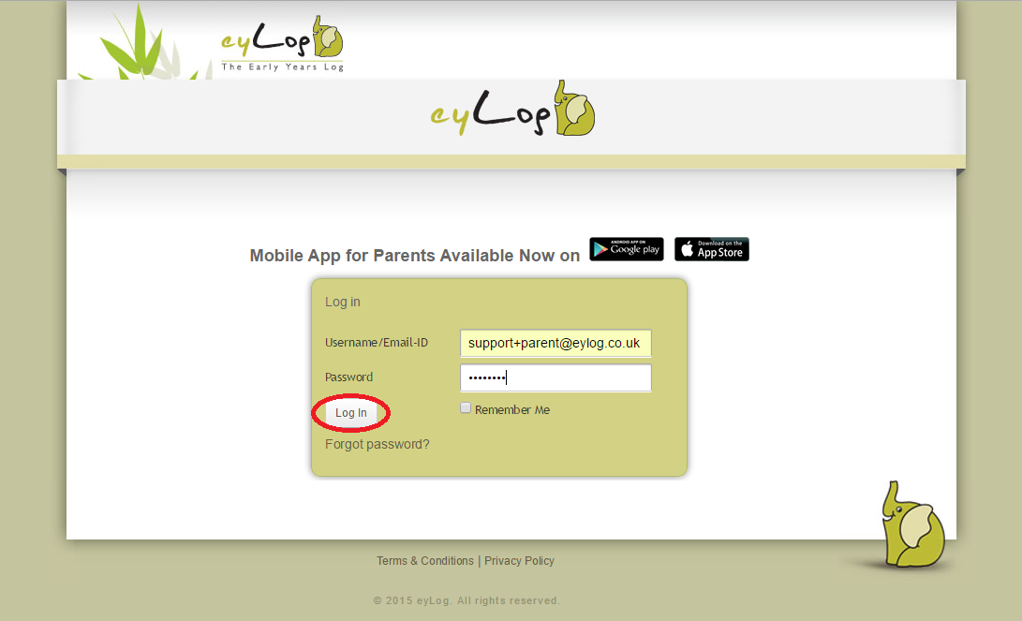
Note: You will be asked to reset your password on first login. Once you reset, you will need to re-login with the new password.

Your Child/Children
Once logged in, you will see the children that you have been provided access to by the nursery, the picture below is a sample screenshot. In case you have more than one child in the same nursery, then all your children should be shown on the screen below (subject to access being provided by the nursery).
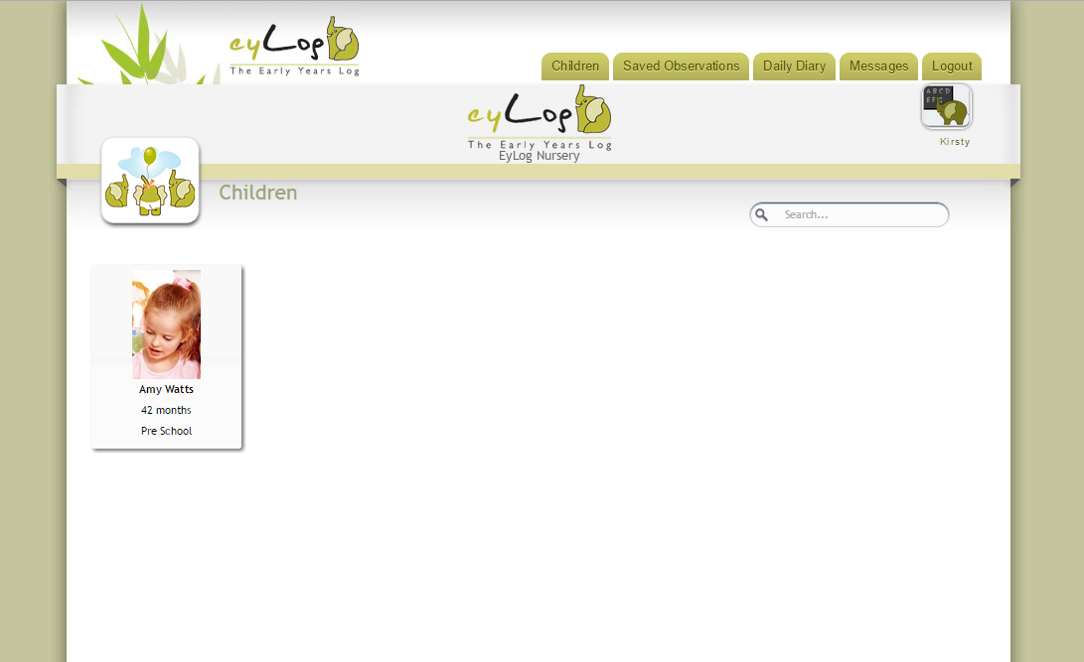

Online Learning Journey
The Learning Journey is the electronic journal created by the nursery capturing the various activities performed by the child during their time there. It shows the observations added by the nursery in reverse chronological order.
You can click on the respective child to view the child’s Learning Journey.
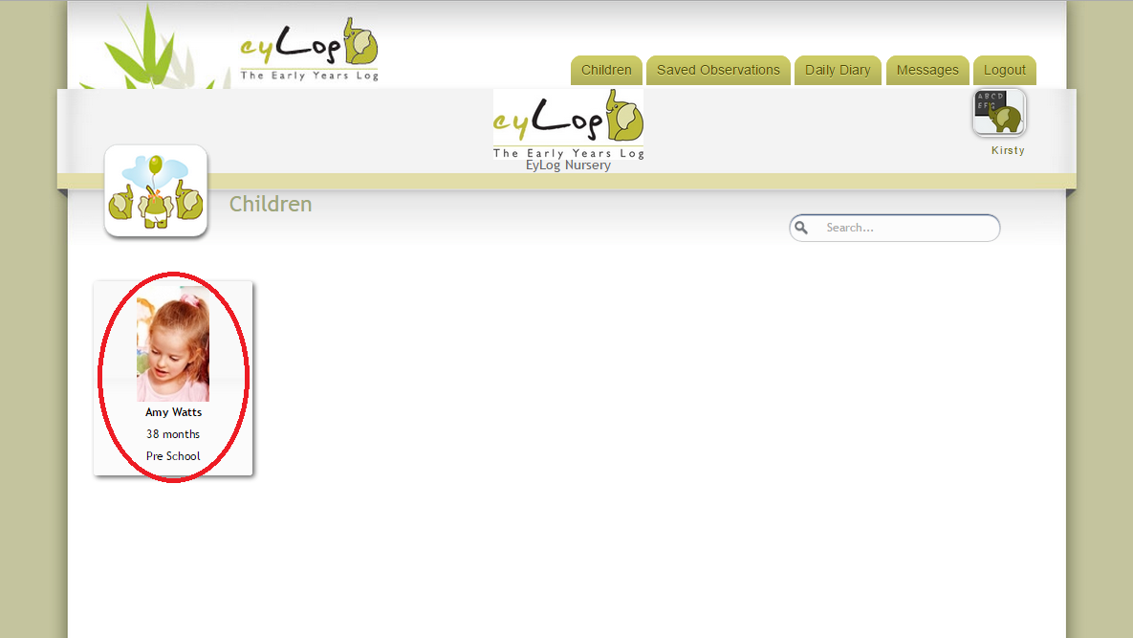

The title of each observation recorded by the nursery indicates the date, time and the person who recorded it. An observation may also have photos, video clips and audio clips associated with it – all of which are accessible by clicking on the image/media icon on the left of the observation or to view additional details click on the observation tabs.
The assessment section shows the details of the EYFS (Early Years Foundation Stage) assessment added to the observation, while the Assessment Level indicates how the child is exhibiting in a particular learning goal. These are added by the key person associated with your child at the nursery.
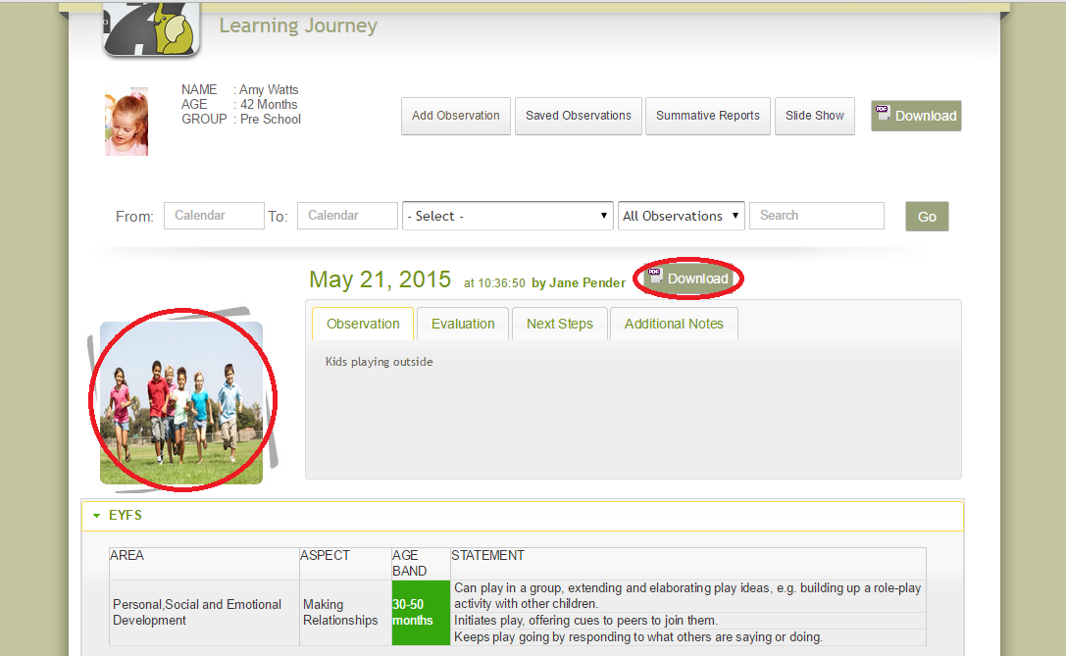
You can filter the Learning Journey to view specific observations using the fields at the top and clicking ‘View’. Or to download the Learning Journey or an individual observation to PDF click on the relevant ‘Download’ button.

Adding Comments
As a parent, you can also comment on an observation which will then be visible to the staff at the nursery. You will receive an email notification to your registered email address as soon as another comment (or a response to your comment) is added to the observation.

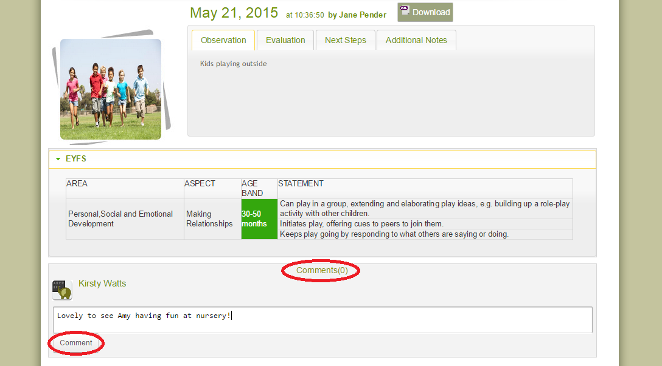

Adding an Observation From Home
A learning journey should be a holistic view of your child’s progress and can be if you, as parents, also contribute to it through observations at home. Using eyLog, you can add your own observations of your child easily at any time through your Parent Portal, which will then be reviewed by the nursery practitioners.
From the Learning Journey, click on the ‘Add Observation’ button.
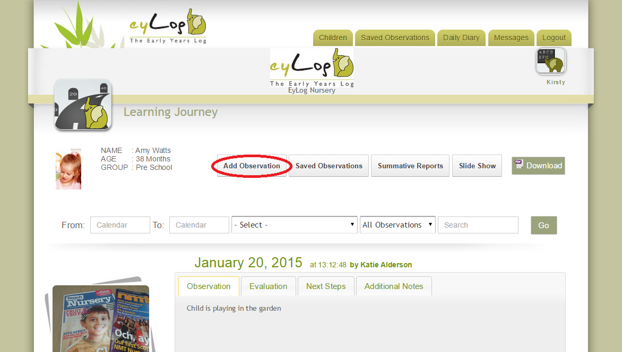
The Add Observation screen allows you to upload photos and provide a description of an activity you have observed the child doing at home. To add photos, click ‘Choose Photos’. Note: Videos are not currently supported via the eyLog web-based Parent Portal.
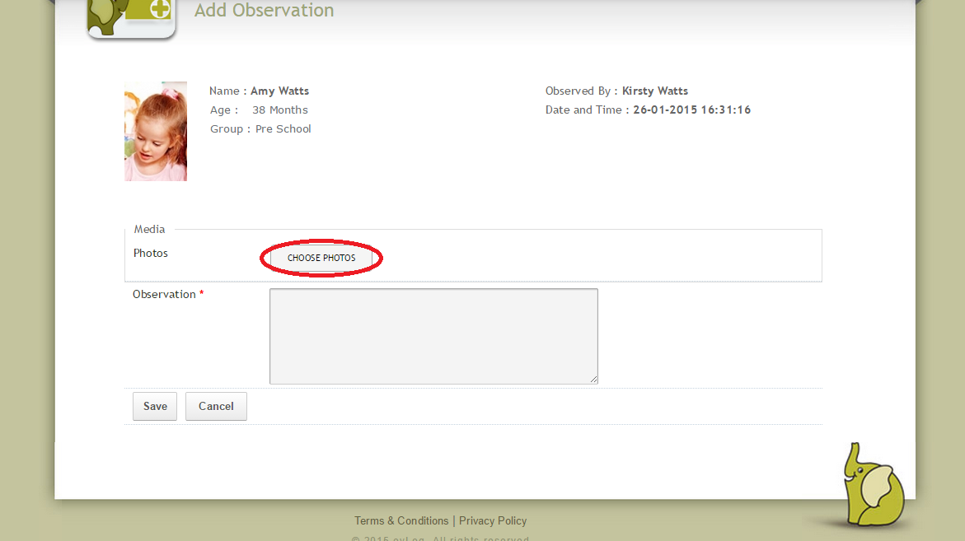

You can then choose from your saved photos on your computer to add to the observation. To select multiple photos use the checkbox in the top left corner of each file to tick the required images. Then click ‘Open’, this will add the chosen files to the observation screen. Note: If you add images once, then try to add more using the same process this will overwrite the initial selection, therefore you need to select all the relevant photos at one time.
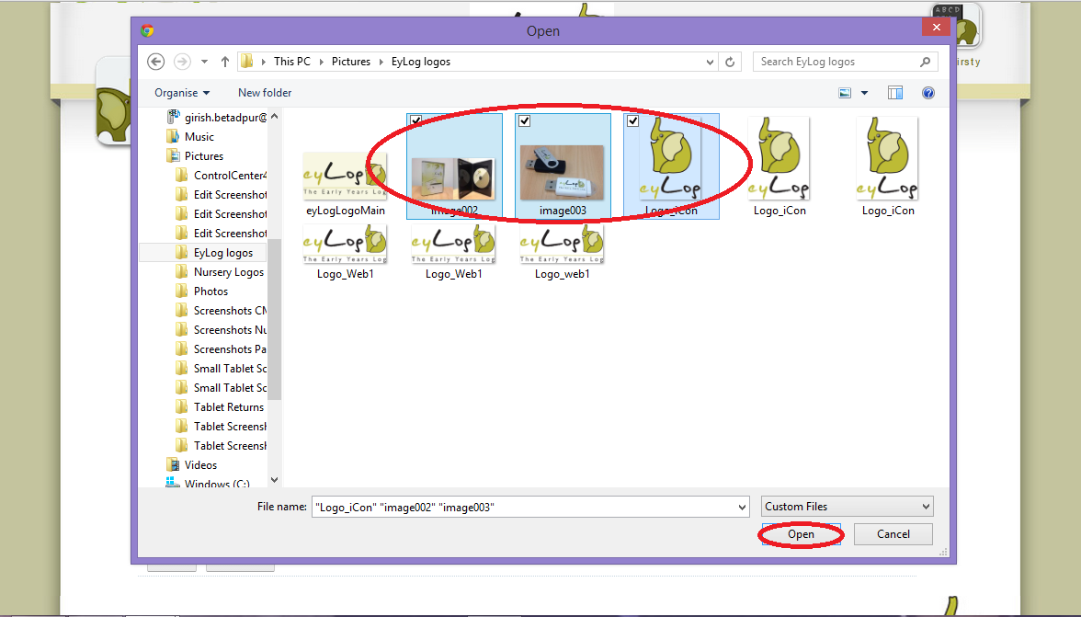
In the Observation box you can write a description of the activity the child has been observed doing and any other information you feel is relevant to their learning progress.
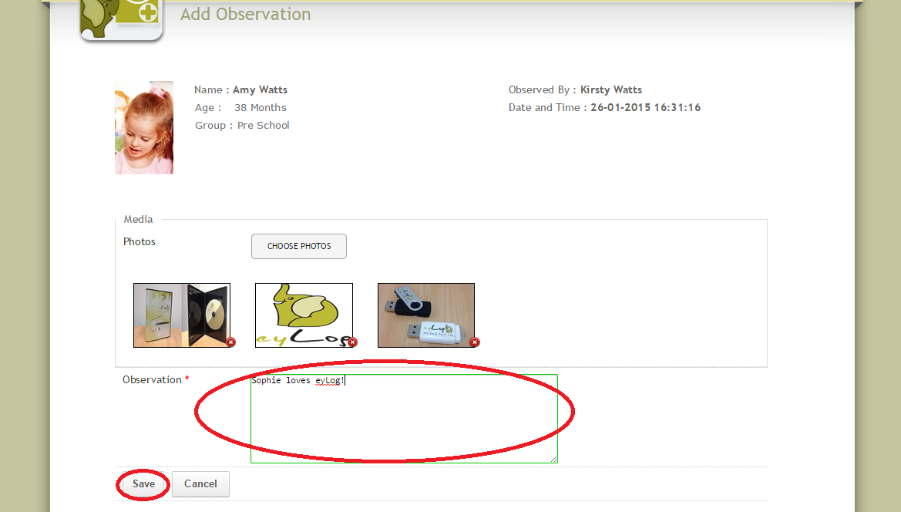
Click ‘Save’ to save the observation. Note: At this point the observation will also be sent to the nursery managers.

Viewing Saved Observations
You can make changes to the observation again if necessary by clicking on the ‘Saved Observations’ tab at the top of the screen. Here you will see all the observations you have added that have not yet been published by the nursery practitioners. Then click on ‘Edit’ next to the observation you wish to amend.
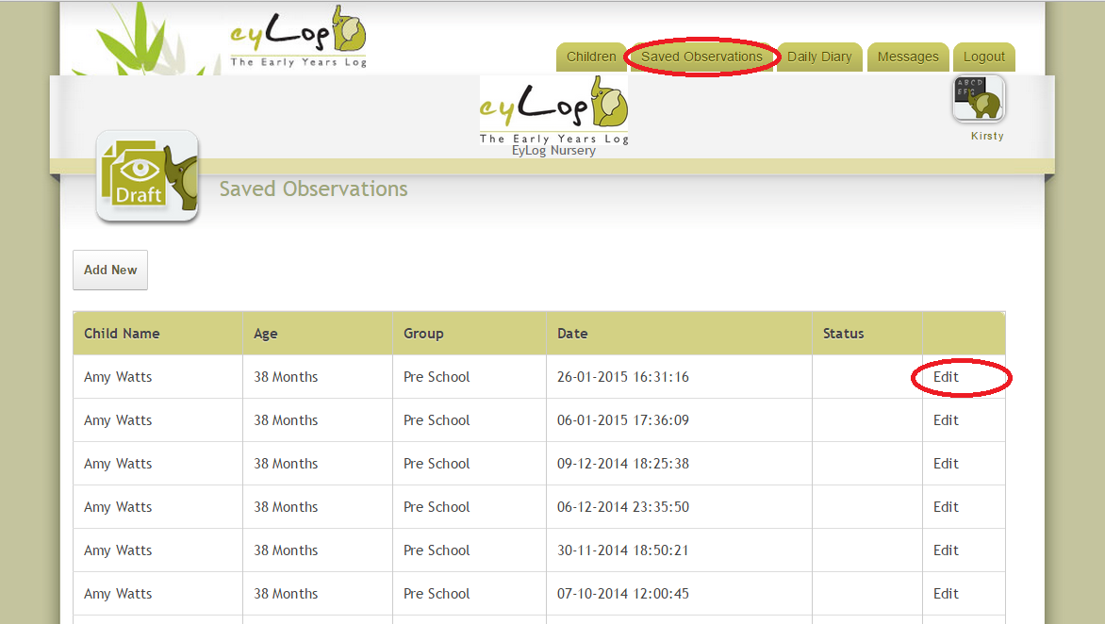
Note: Saving an observation does not automatically make it part of the learning journey. The nursery practitioners will review your observation and update it with additional details such as analysis, and framework assessments. Your observation will be available on the learning journey of the child, only after the staff member has reviewed and submitted the observation to the learning journey.

Your Messages
One of the features of eyLog is an integrated messaging system between yourself, as the parent, and the Managers of your child’s nursery. Managers can send out important information that they feel is relevant to you and your child via your Parent Portal and vice versa.

Receiving Messages
If you have received a new message through eyLog you will firstly receive an email notification. Note: The message content between the nursery and yourselves is not sent via email for security reasons.
You can access your new or saved messages easily at any time through your Parent Portal. Once you are logged in, click on the ‘Messages’ tab at the top of the screen. Note: If you have any new messages the little red bubble will show with the number of unread messages in your inbox.
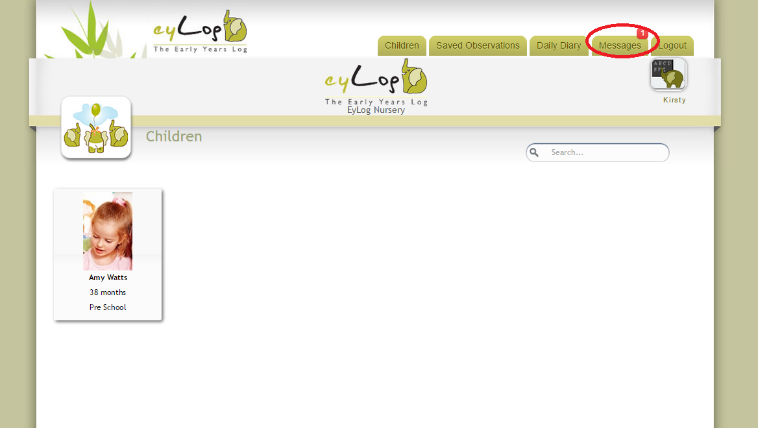
This will open up your eyLog inbox. Unread messages will be listed in bold and can be opened by clicking on the message subject.
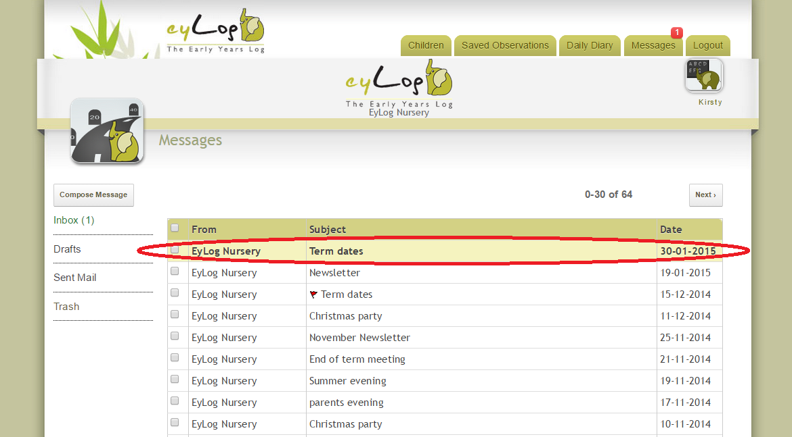

From here you can read your message, then either click ‘Delete’ to erase the message or to reply to the message, click on ‘Reply’. Note: The message will continue to be available in you inbox if you do not choose to delete it.
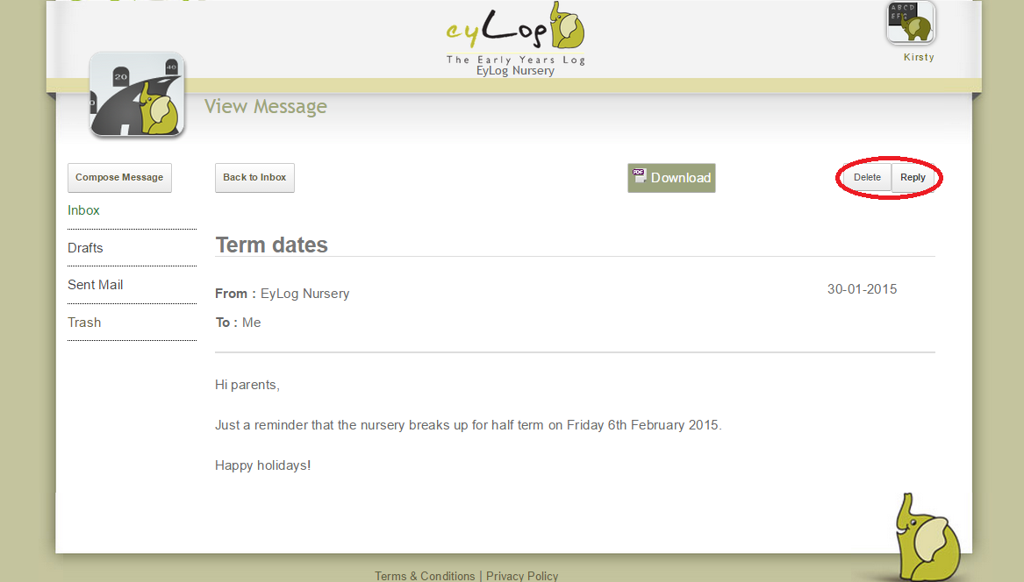

Composing a Message
The messaging functionality provides a ‘rich text’ message editing facility to compose messages. Basic features such as choosing font style and size, bold/italics/underlining/highlighting, coloured text, bulleted and numbered items are available for you to use.
From here you will be able to type your message to the nursery into the ‘Message’ box and click ‘Send’. A notification will then be sent by email to the nursery manager and the messages will be available on-line when they log in to their system. Note: You can also choose to ‘Save’ the message to come back to at a later time if required.
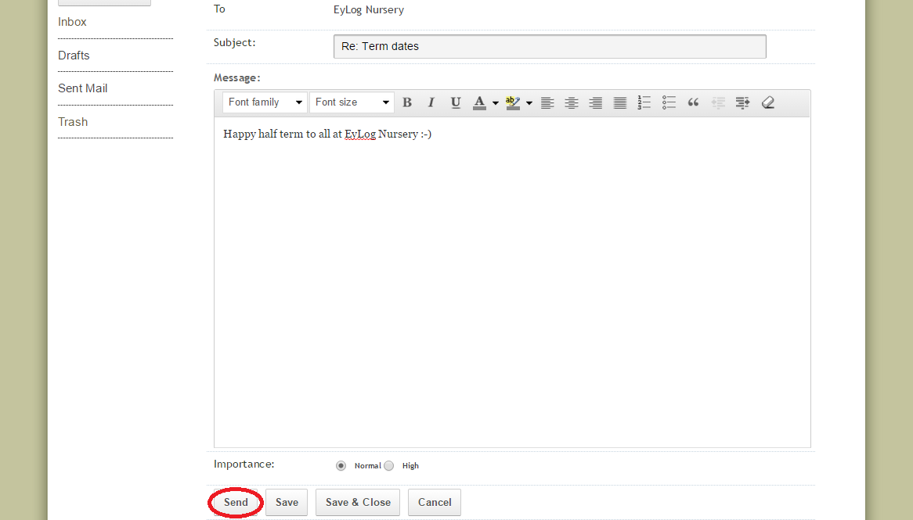

Your Child’s Daily Diary
The eyLog daily diary feature enables nurseries to record key information about your child’s day at the nursery - what the child ate, when the child slept, nappy changes and toilets. This can be shared with you on a daily basis along with the child’s register, a summary of the day’s observations and any additional notes.

Adding Notes to a Daily Diary
The daily diary can be used as a two way communication between parents and the nursery and as such can be started by you, as the parent, easily at any time from you Parent Portal.
Once you are logged in, click on the ‘Daily Diary’ tab at the top of the screen.
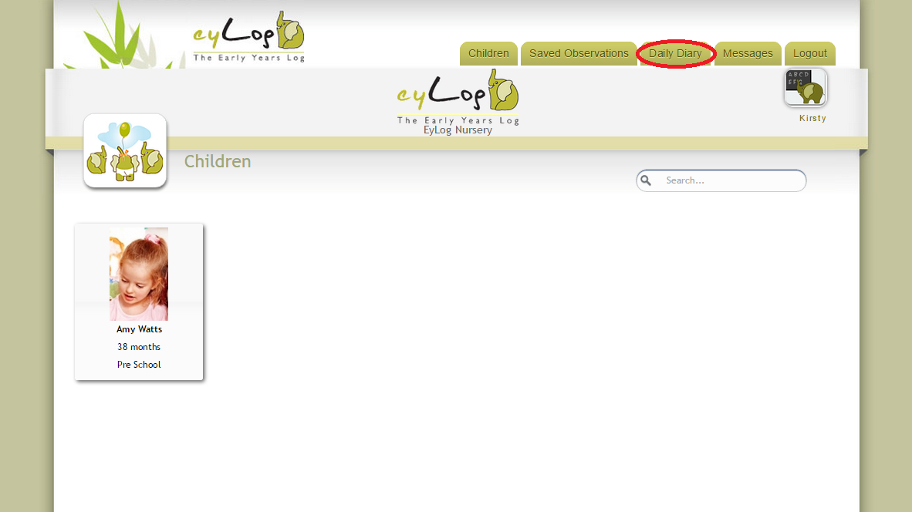
This will open up the daily diary tracker. To add a new entry, click on the ‘+’ sign under the relevant date.
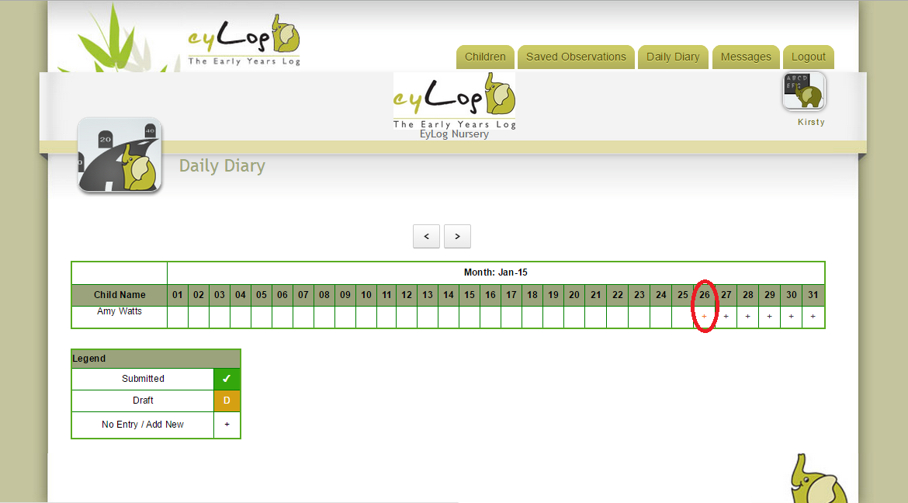

From the Daily Communication Diary screen, you can change the date by clicking in the ‘Select Date’ box and selecting the relevant day from the calendar. Note: You are not able to select a date in the future.
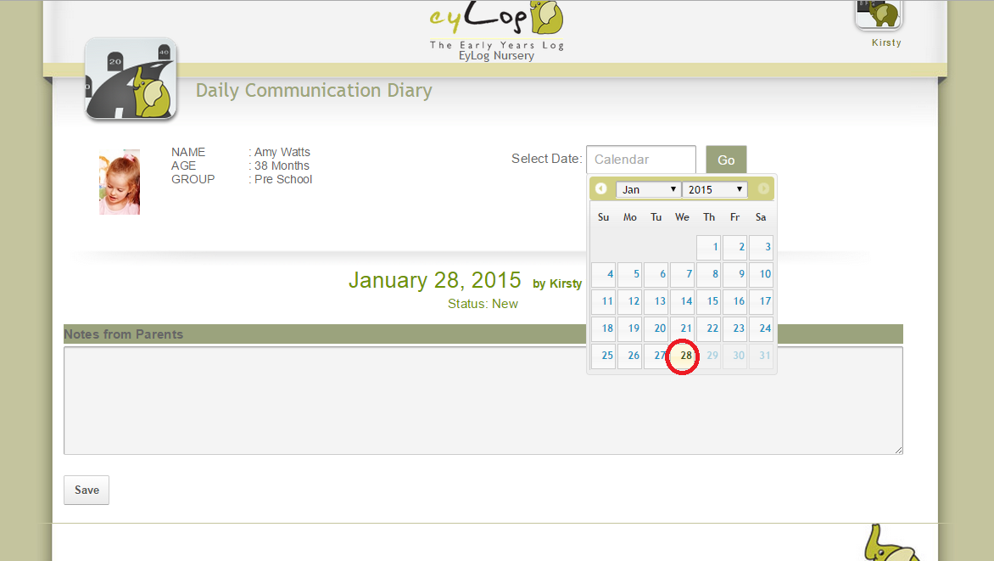
You can then write a message in the ‘Notes from Parents’ box.

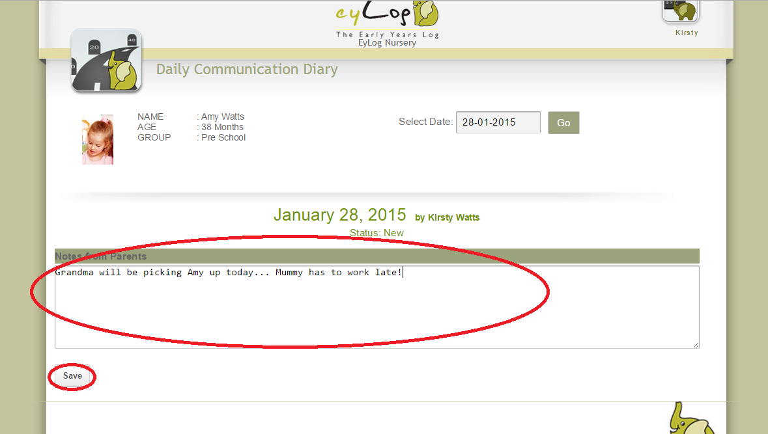
Once you click ‘Save’ your message will be available to the nursery practitioners when they open your child’s daily diary from the nursery.

Viewing a Daily Dairy
Once you have collected your child from the nursery the practitioners will publish their daily dairy which will then be available to view from your Parent Portal.
Once you are logged in, click on the ‘Daily Diary’ tab at the top of the screen.
This will open the monthly view of the daily diary tracker. This tracker shows all the entries that the nursery has shared with you. To open the respective daily diary entry click on the ‘✓ ’.
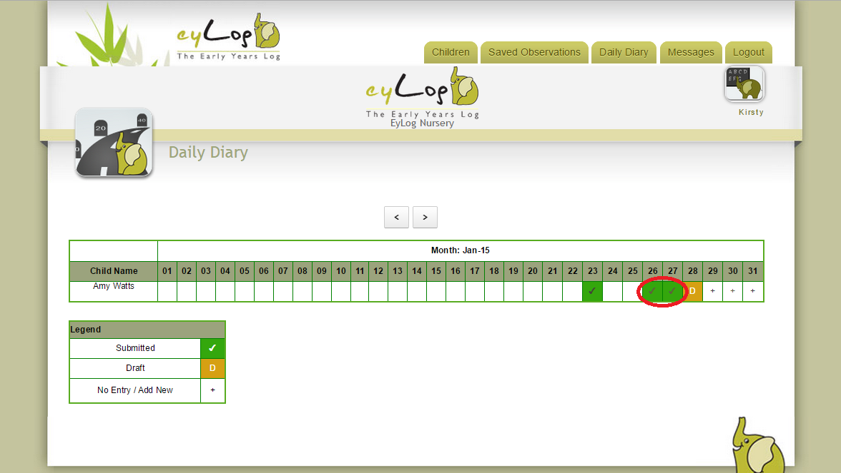

The daily diary entry for the selected day will open up as below with respective tabs for information about what your child ate, sleep times, bottle/milk details, nappies and toileting.
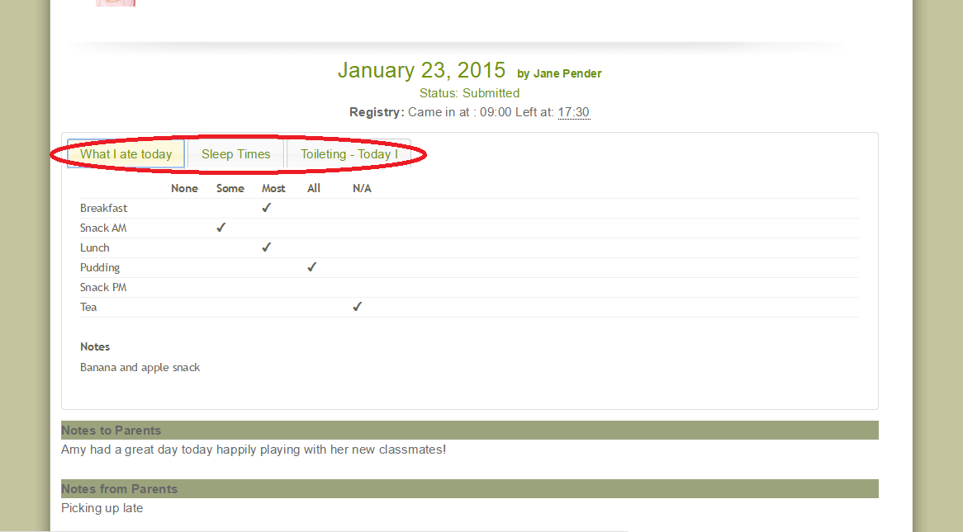
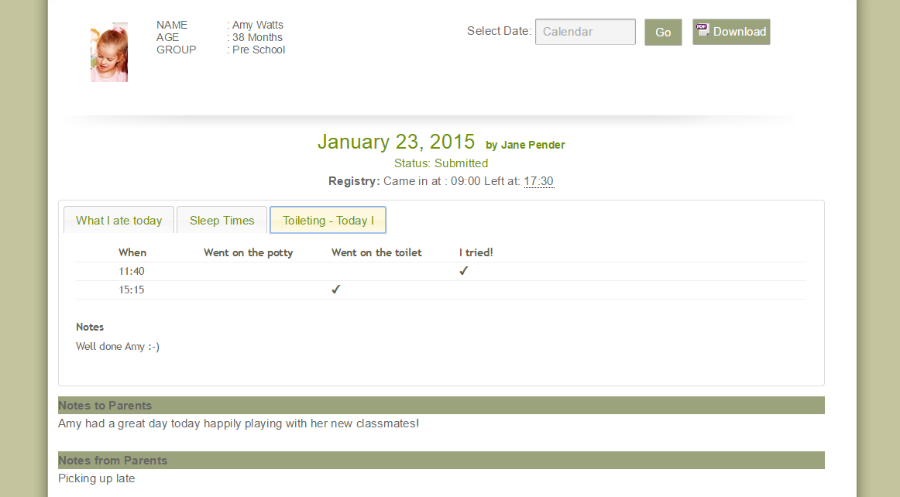

Frequently Asked Questions (FAQs)
My child's nursery is using eyLog. How can I as a parent log-in to eyLog to view my child's learning journey?
Check with your child’s nursery to see if they are sharing the learning journey with the parents. Most nurseries do! The nursery should register you as the child’s parent on the system. Once that is done, you will automatically receive the log-in details by e-mail. In case you haven’t received this mail with the account details, please also check your Spam folder as some mail servers may accidentally mark our system mails as spam.
Please do make sure that you log-in using the URL that would have been provided in the e-mail. It will be something like: eylog.co.uk/<nursery-name> or eylog.co.uk/<number>
I have forgotten my password. How do I re-set it?
On the log-in screen, there is a link labelled ‘Forgot Password’. Click on this link and enter your e-mail ID. If you are already registered on the system, the system will send you a mail with a link to reset the password. Click on the link and follow the instructions to reset the password.
Can both I and my partner get access to eyLog as parents?
Yes. More than one person can be registered as parents/carers of a child and all of them would then get separate access to the child’s learning journey through their own user-ID and password. Whenever observations are added to the learning journey, notifications would be sent to all the registered parents.
I have two kids who are going to the same nursery. Will I need two log-in IDs?
No. If you are registered as a parent for both the children, then once you log-in to eyLog, you will be able to view both the children, look at their learning journeys and add observations/comments through the same log-in.
Why are the observations that I have added as a parent not immediately visible in my child's learning journey?
Observations added by parents need to be reviewed by the nursery staff before they become part of the child’s learning journey. Check with your child’s key person at the nursery in case your observations haven’t been reviewed even after a few days.
Where is my child’s data stored?
The data captured through the eyLog tablets at the nursery as well as the data provided through the web-interfaces are all stored on secure “cloud” servers located in UK. Very minimal information is stored on the tablets.
How is the data transferred from the tablet to your servers and to the parents? How is this protected?
All communication between the tablets/servers/browsers is through HTTPS and encrypted using SSL (Secure Sockets Layer). You will see the green bar in the browser indicating HTTPS (encrypted) communication.

Will the details of the children (name/photo) appear on Google's search results?
No. The names of children/practitioner, etc., are all stored in secure databases which are not accessible to any search engine. All access to nursery data is protected by user-IDs and passwords preventing any search engine from crawling them.
Who is your cloud server service provider? Who has access to these servers?
We use Rackspace which is UK’s leading cloud provider. Please refer to Rackspace’s ‘Security and Compliance’ policies for more details. Only the core eyLog team have access to the individual production cloud instances.
How long is the data of the children stored on your servers and by what measures do you safely remove this when the times comes
When a child exits the nursery, the nursery has the option to remove the child from the system. They or you as the parents (depending on the nursery’s policy) can request the entire learning journey including photos/videos/etc., on a DVD or USB. Once the child is removed from the system, the nursery/parent have 30 days to request for this DVD/USB after which all data of the child will be permanently removed from the system.
What happens to backups when they are no longer required?
There are a fixed number of previous backups saved at any given point in time and the older ones are over-written as new back-ups are created. Access to these back-ups is available only to the core eyLog team.

Disclaimer
The information contained in this document is the proprietary and exclusive property of eyLog Ltd except as otherwise indicated. No part of this document, in whole or in part, may be reproduced, stored, transmitted, or used for any purpose without the prior written permission of eyLog Ltd.

The information contained in this document is subject to change without notice. The information in this document is provided for informational purposes only. eyLog Ltd. specifically disclaims all warranties, express or limited, including, but not limited, to the implied warranties of merchantability and fitness for a particular purpose, except as provided for in a separate software license agreement.

Privacy Information
This document may contain information of a sensitive nature that is protected under copyrights and patents. This information should not be given to persons other than those directly addressed or involved in the decision making process regarding the procurement of the application without the explicit permission of eyLog Ltd.

eyLog Ltd. is a limited company registered in England and Wales. Registered Number: 07939645
ICO Registration Number: Z3588543
Office Address: Margaret Powell House, 401 Midsummer Boulevard, Milton Keynes, MK9 3BN

eyLog Ltd (is registered in England and Wales - Company Number: 07939645)
145-157 St John Street, London – EC1V 4PW, United Kingdom
Tel: +44(0)2031 433 063; e-Mail: info@eylog.co.uk; Web: www.eylog.co.uk

